OFFICIAL COORDINATION REQUEST FOR
NON-ROUTINE OPERATIONS AND MAINTENANCE

COORDINATION TITLE: 19BON18 Cascade Island Subsidence Project

COORDINATION DATE: June 26, 2019

PROJECT: BON

RESPONSE DATE: July 11, 2019 (FPOM meeting)

Description of the problem: The US Army Corps of Engineers, Portland District (USACE), plans to install a new access bridge to Cascade Island and repair three crane pads necessary to perform routine maintenance on and around the existing fish ladder. Phase one of the project is a supply contract to purchase a Mabey Johnson bridge (or similar type) which will be installed by the 671st Engineer Company at no cost to USACE. Limited availability of the 671st Company along with the Project requiring bridge installation prior to 15 December dictates the timing of the bridge to be installed outside of the in-water work window. Additionally, the Project will remove hand rails, two fence corners and scrape dirt from the edge of the fish ladder in early August to be ready for the bridge work in October. Following the bridge installation, phase two will be to repair the crane pads during in-water work window. Only one 8-hour day will be needed to install the Mabey Bridge with a preferred date of October 18, 2019.

Type of outage required

- Impact on facility operation (FPP deviations): No outages are required for the proposed work. The work falls within the 50’ of the fish ladder.

- Impact on unit priority: None

- Impact on forebay/tailwater operation: None.

- Impact on spill: None.

Dates of impacts/repairs:

- August 5-8, 2019:
  - Project will remove hand rails from current bridge.
  - Project will remove two fence posts from corners of north edge of current bridge next to fish ladder.
  - Project will scrape dirt and moss from on top of fish ladder on corner that will support the new bridge.

- October 18-20, 2019:
  - Mobilize crews and equipment
  - Mabey Bridge Installation – requiring one 8 hour day
  - Demobilize crews and equipment

- Dec 15, 2019 -Feb 01, 2020:
  - Repair three crane pads. – this work will take place during the in-water work period.

Analysis of potential impacts to fish
- 10-year average passage by run during the period of impact for adults and juvenile listed species, as appropriate for the proposed action and time of year.
  - 05-08 August- This work will be completed in August during the same time frame as the ROV inspection in between the major fish runs. See the table and graph below for ten year averages.
  - 18-20 October - During the bridge installation, low numbers of fall run Chinook and Steelhead are present daily. See the table and graph below for ten year averages.

Date | CHN | STT | SOC | COHO
8/5 | 583 | 5115 | 48 | 2
8/6 | 761 | 5564 | 40 | 4
8/7 | 780 | 6185 | 34 | 5
8/8 | 831 | 6289 | 26 | 8
10/18 | 969 | 423 | 0 | 1462
10/19 | 589 | 282 | 0 | 1132
10/20 | 693 | 224 | 0 | 848
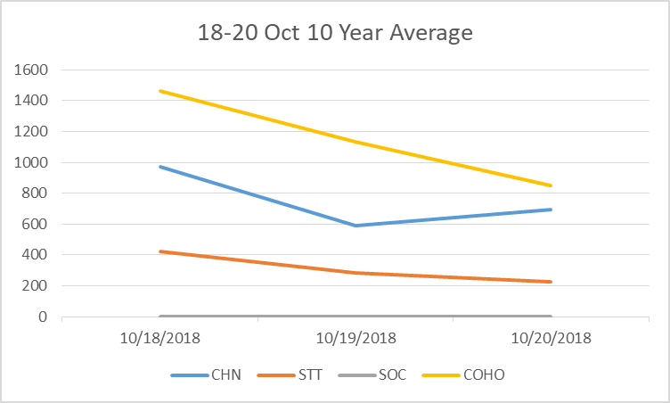
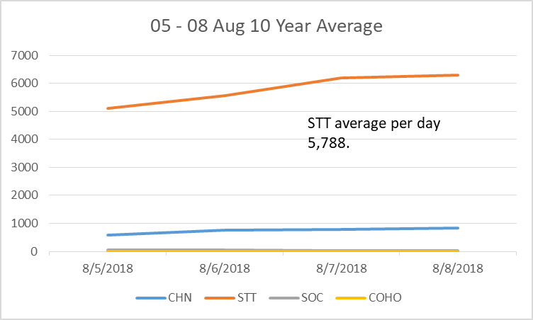

- Statement about the current year’s run (e.g., higher or lower than 10-year average).
  - 2019 is well below the 10-year average for all salmonid species.
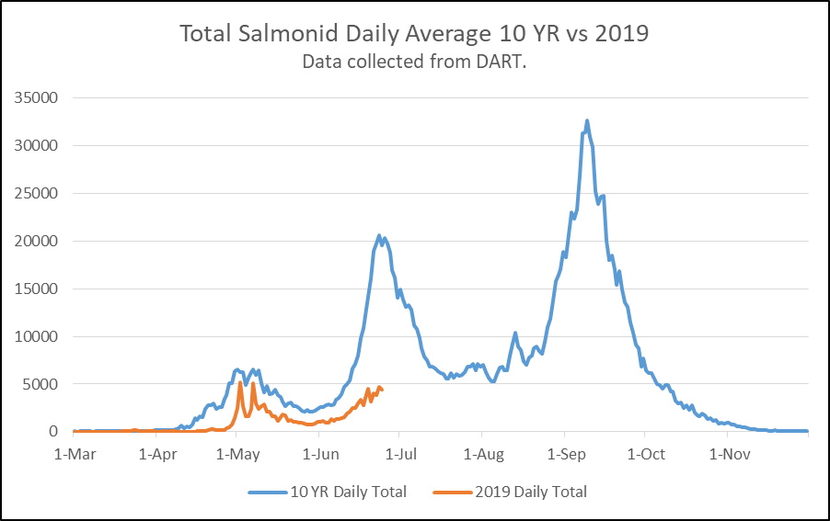
- Estimated exposure to impact by species and age class (i.e., number or percentage of run exposed to an impact by the action).
  - 05-08 August – Although there are Chinook, Coho and Sockeye present, Steelhead more than any other species could be affected by this action.
  - 18-20 October – Later runs of Chinook, Steelhead and Coho could be impacted.
- Type of impact by species and age class (increased delay, exposure to predation, exposure to a route of higher injury/mortality rate, exposure to higher TDG, etc.).
  - 05-08 August – Low level noise due to the close proximity of the work is the only expected impact. This work will not affect ladder criteria. Impacts due to predation, delay, injury/mortality, or TDG exposure is thought to be minimal.
  - 18-20 October – The installation of the bridge will create noise and possibly some vibration issues. Fish could be delayed by the noise but the ladder will be in criteria and all other passage routes will be open. The peak of the Fall Chinook and Coho runs will have passed already.

Summary statement - expected impacts on:
- Downstream migrants
This operation should not affect unit priority or spill operations; impacts to juveniles is thought to be minimal if any.
- Upstream migrants (including Bull Trout)
Impacts to returning adults are thought to be minimal to low given the ladder will remain in criteria during this work period.
- Lamprey
Impacts to Lamprey are thought to be minimal as all lamprey passage structures will remain in service; the Cascades Island LPS is the least utilized LPS at Bonneville.
Comments from agencies

Final coordination results

After Action update (After action statement stating what the effect of the action was on listed species. This statement could simply state that the MOC analysis was correct and the action went as expected, or it could explain how the actual action changed the expected effect (e.g., you didn’t need to close that AWS valve after all, so there was no impact of the action). List any actual mortality noted as a result of the action)

Please email or call with questions or concerns.
Thank you,
Erin

Erin Kovalchuk
NWP Operations Division Fishery Section
Columbia River Coordination Biologist
Erin.H.Kovalchuk@usace.army.mil

And

Ben Hausmann
Chief of Fisheries
Bonneville Dam
Benjamin.J.Hausmann@usace.army.mil

